10 Ways Adult Stem Cells Advance Tissue Regeneration Studies
Posted by Luke Doiron on Jan 27, 2015 6:00:00 AM

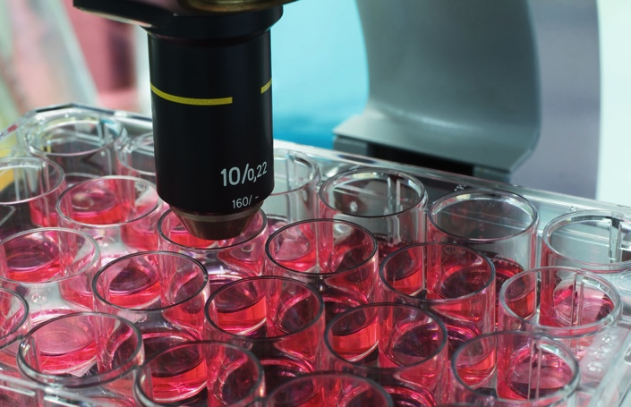
The adult stem cell is a cell that can be found among specialized, more differentiated cells in a tissue or organ. They have 2 unique features:
- Self Renewal (ability to propagate)
- Multilineage differentiation or Multipotency (ability to develop into all major tissue types)
These qualities make adult stem cell research a very attractive and promising arena in the field of Regenerative Medicine. Researchers are expanding their understanding of identified adult stem cells and working to isolate them for cells for the liver, kidney, heart and even neural tissues. This work provides the basis for ongoing preclinical and clinical trials for organ and tissue regeneration from healthy adult stem cells.
Hematopoietic stem cells (HSCs) and mesenchymal stem cells (MSCs) are two of the most important populations of adult stem cells. The application of these stem cells offers a new insight in treating various pathological conditions, through replenishing cells of specific functions by turning on or off the differentiating program within quiescent stem cell niches. Apart from that, they are also capable of travelling through the circulation, migrating to injury sites and differentiating in order to enhance the regeneration process.
Stem cell mobilization, which is defined as the forced egress of stem cells from the bone marrow to the peripheral blood (PB) using chemokine receptor agonists, is an emerging concept for enhancing tissue regeneration. It is widely accepted that adult stem cells are able to circulate between organs for repair and maintenance of tissues; MSCs from distal sites migrate to repair local wounded tissues.
The strategy of purposefully mobilizing stem cells began with the original observation that chemotherapy increases circulating CD34+ cells (a marker for hematopoietic stem cells [HSCs] and progenitor cells) in patients undergoing cancer treatment. This technique is considered the standard of care for adult patients who need bone marrow transplants to reconstitute hematopoiesis after chemotherapy for certain cancers. 2
Bone marrow derived hematopoietic stem cells (HSCs) provide a critical role by generating all of the new mature and differentiated white and red blood cell lineages along the lifespan of the individual. They can be used for the treatment of many conditions and diseases by reconstituting the hematopoietic cell lineages and immune system defense. These include:
- macular degeneration
- spinal cord injury
- burns
- heart disease
- diabetes
- osteoarthritis
- rheumatoid arthritis
- chronic bowel disorders
- diabetes
- cancer
According to the National Stem Cell Foundation, researchers are expanding their understanding of ways to isolate adult stem cells for the purposes of tissue regeneration, and there are key considerations in the advancement of this research.
- Can be found in abundant quantities (millions to billions of cells)
- Can be harvested by a minimally invasive procedure
- Can be reliably and reproducibly be differentiated along multiple cell lineage pathways
- Can be safely and effectively transplanted to either an autologous or allogeneic host
- Can be manufactured in accordance with current Good Manufacturing Practice (GMP) guidelines

